CS 340 Project Two – Dashboard README - Rikuto Ota

# Project Overview

This project is a dashboard app made for Grazioso Salvare, a rescue dog training company. The app helps them find good dogs for different kinds of rescue training. It uses a MongoDB database and a web dashboard built with Dash. Users can easily filter and view dog data.

# Required Functionality and Screenshots

The dashboard includes:  
- A data table showing all animals (no filters at first)  
- Filter buttons for:  
 - Water Rescue  
 - Mountain or Wilderness Rescue  
 - Disaster or Individual Tracking  
 - Reset (shows all data again)  
- An interactive table that updates based on filters  
- A map showing dog locations  
- A bar chart showing number of dogs by breed  
  
Below are screenshots showing these features working (with my name and the Grazioso Salvare logo included):

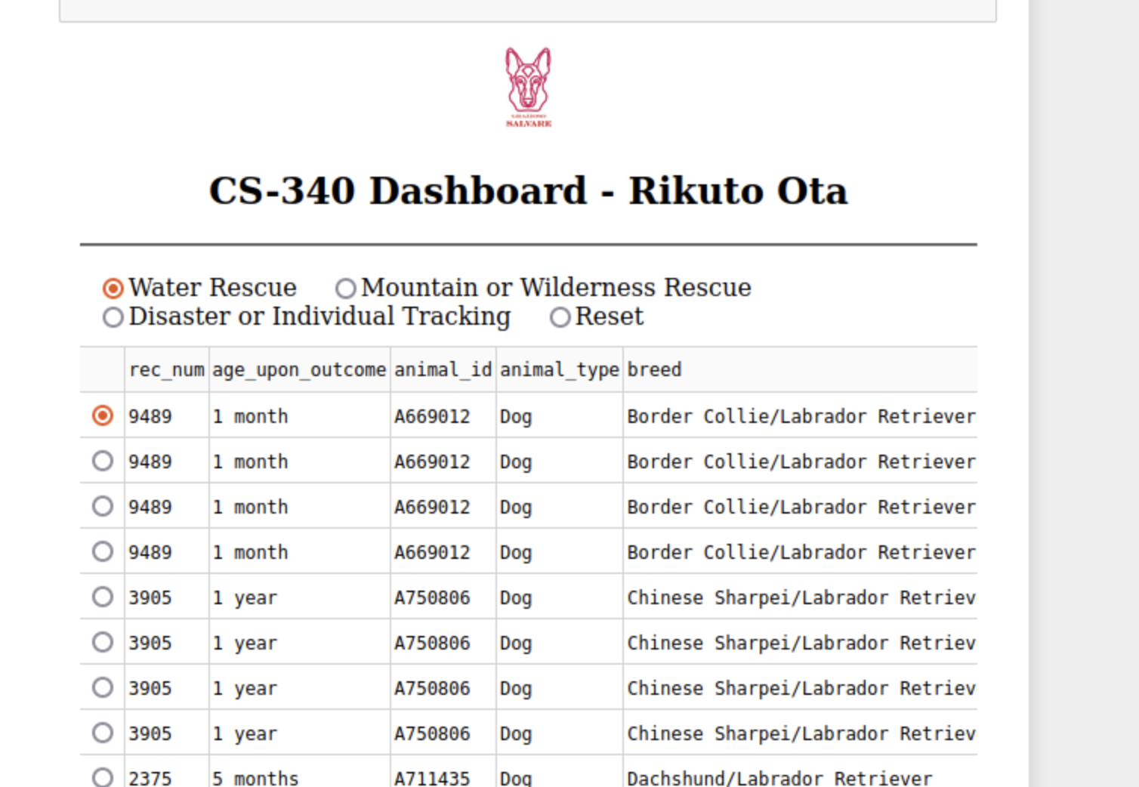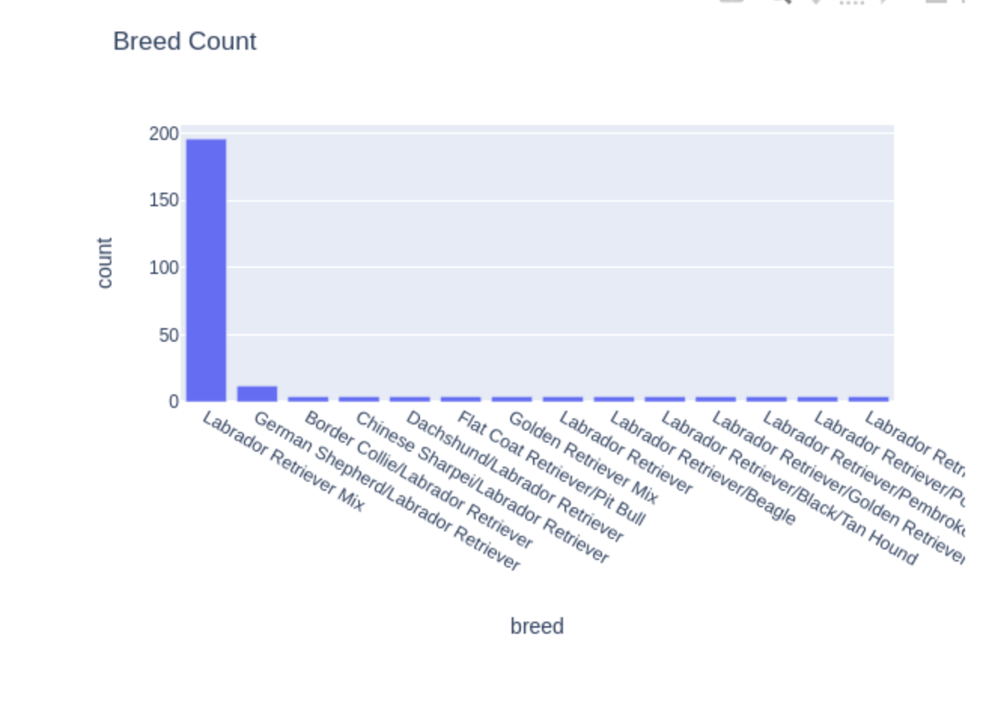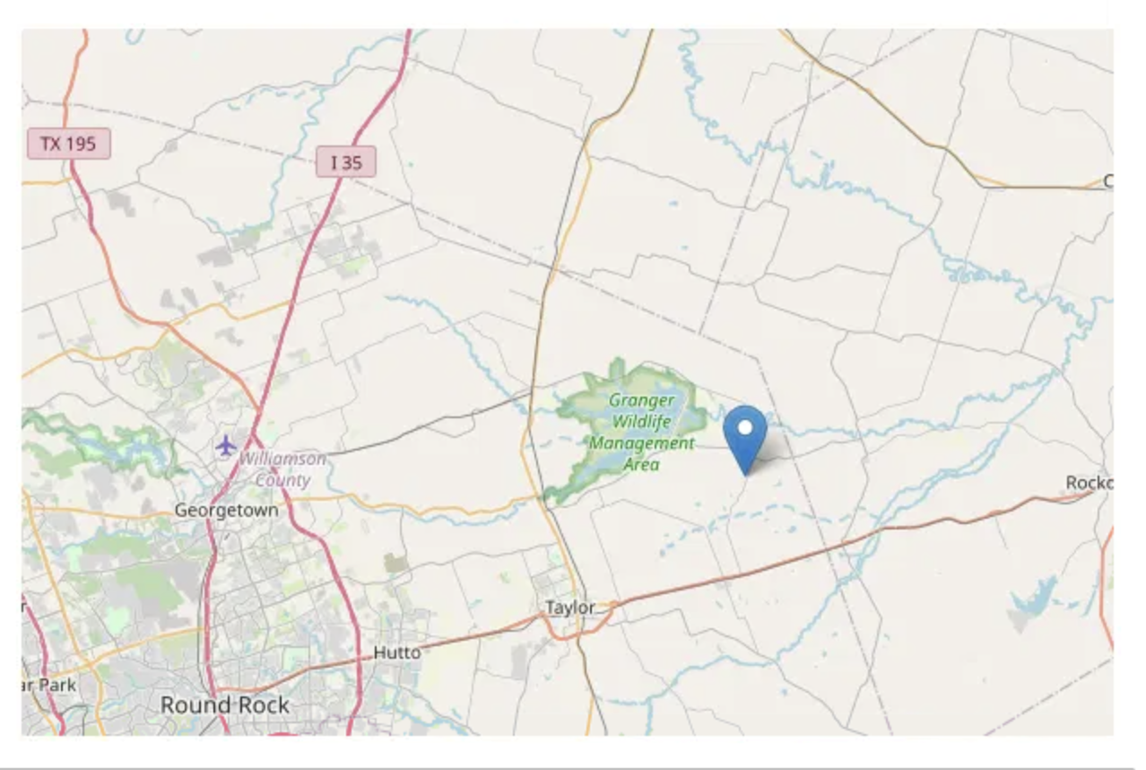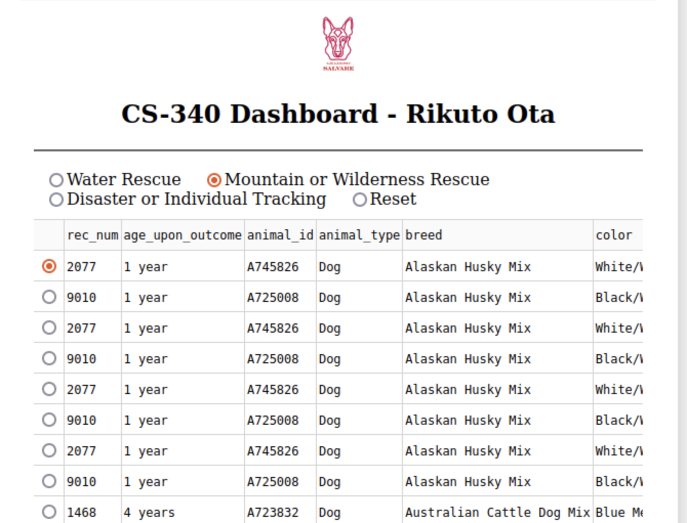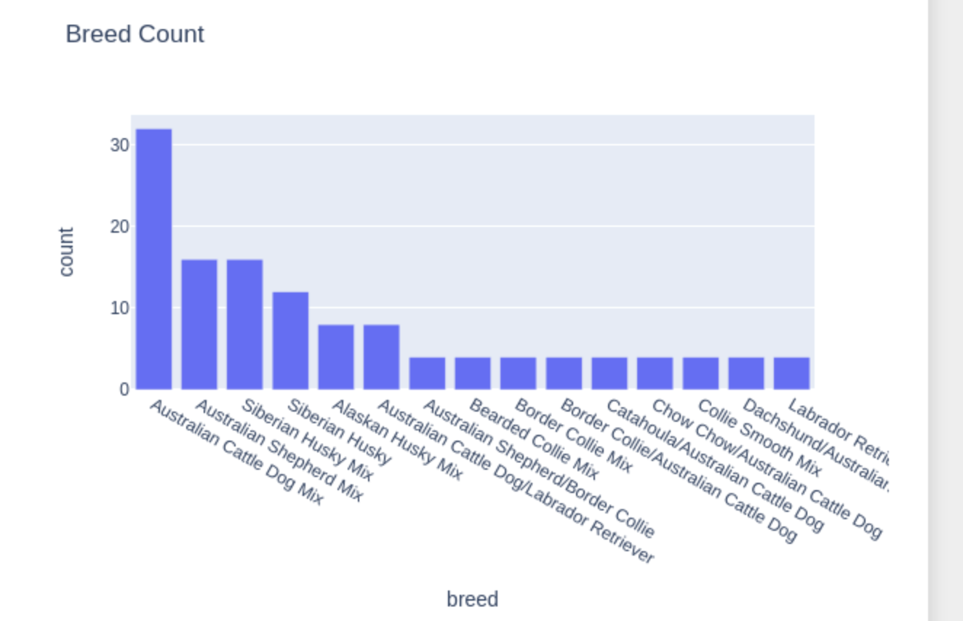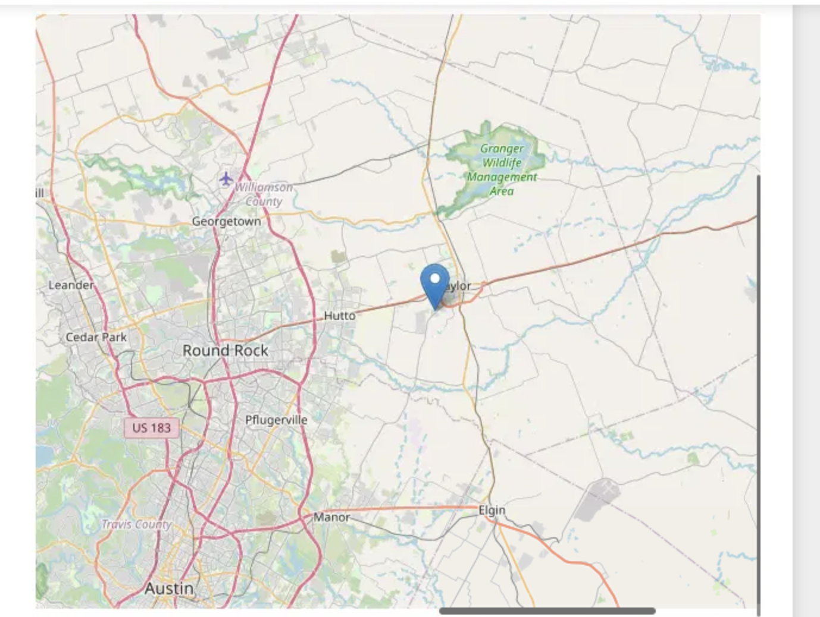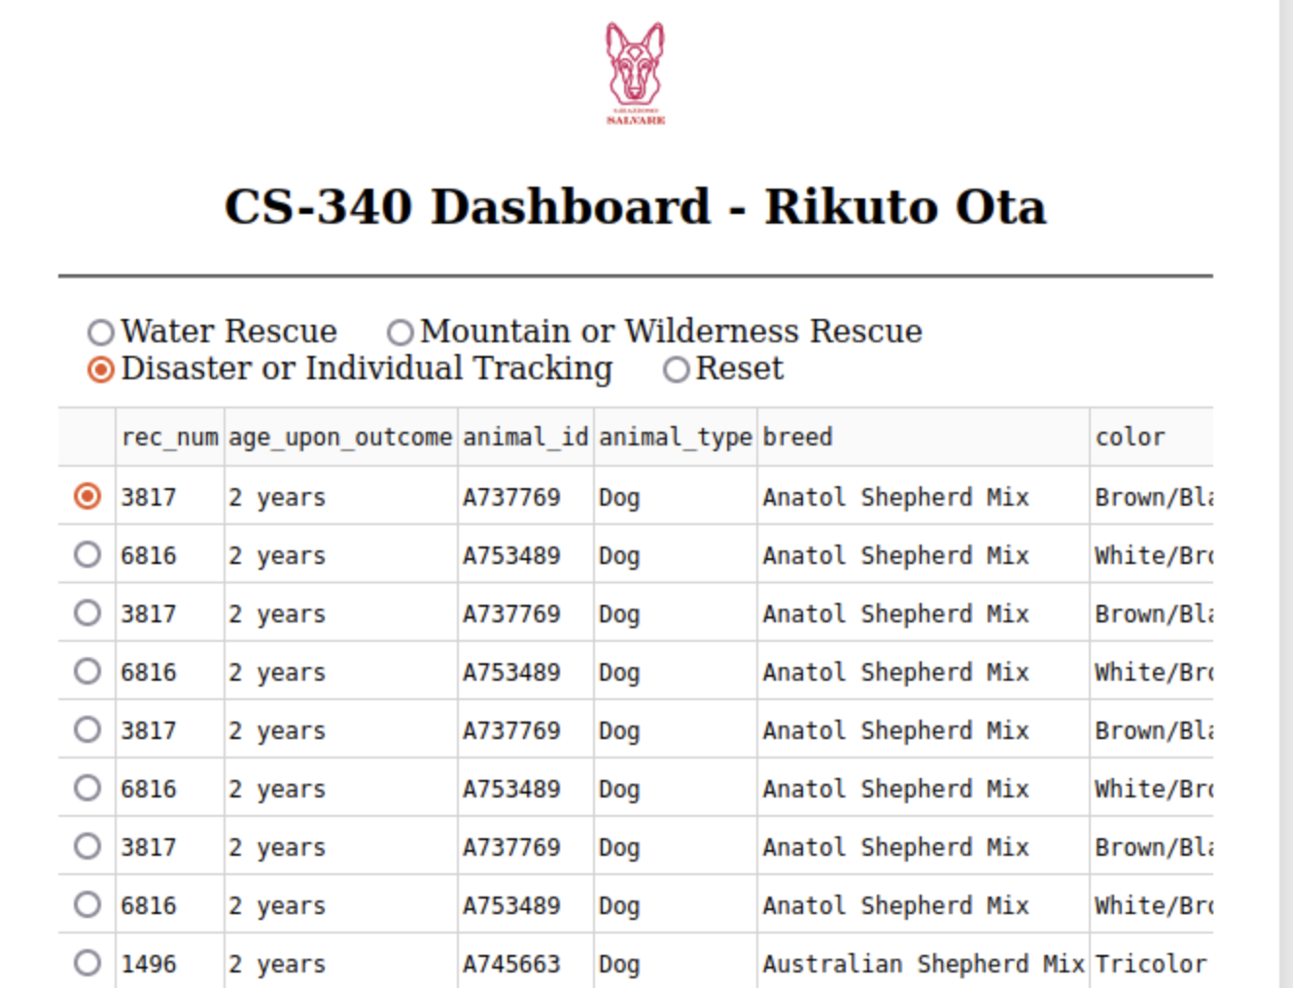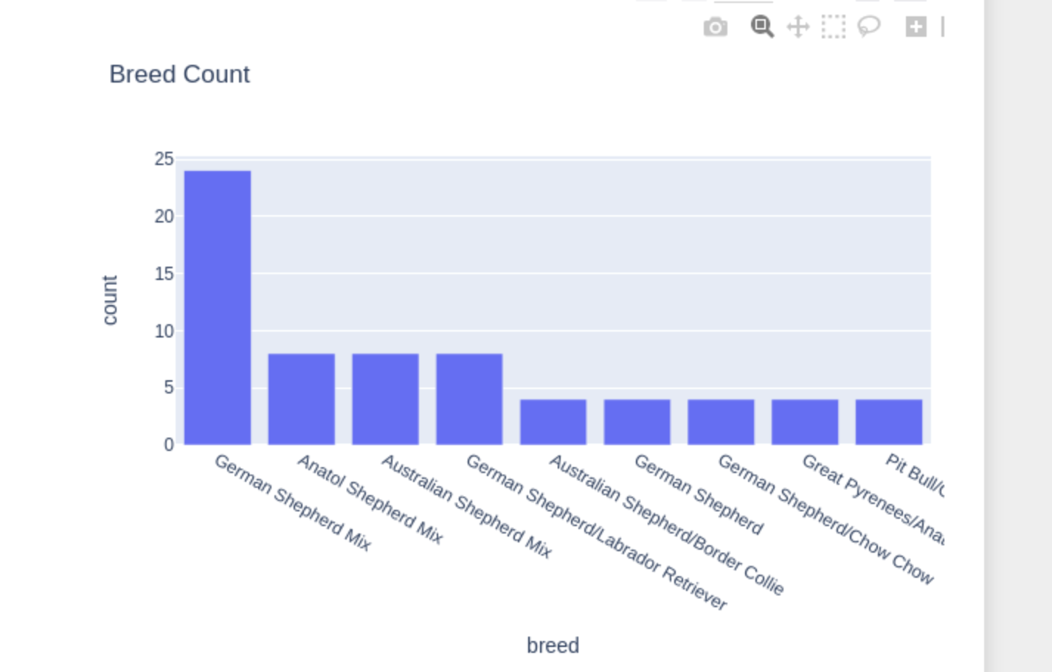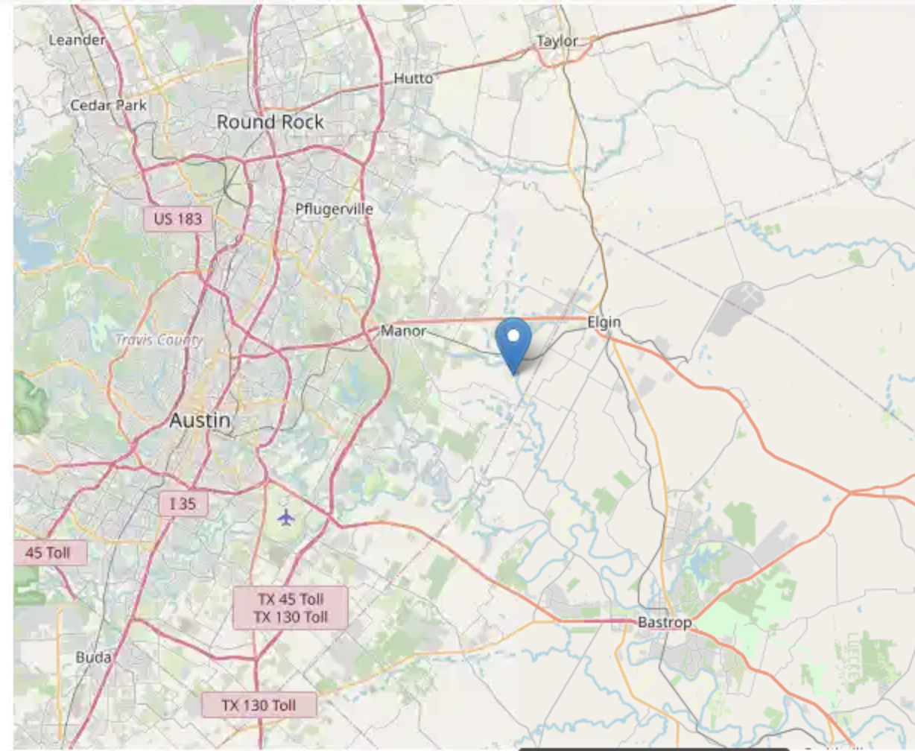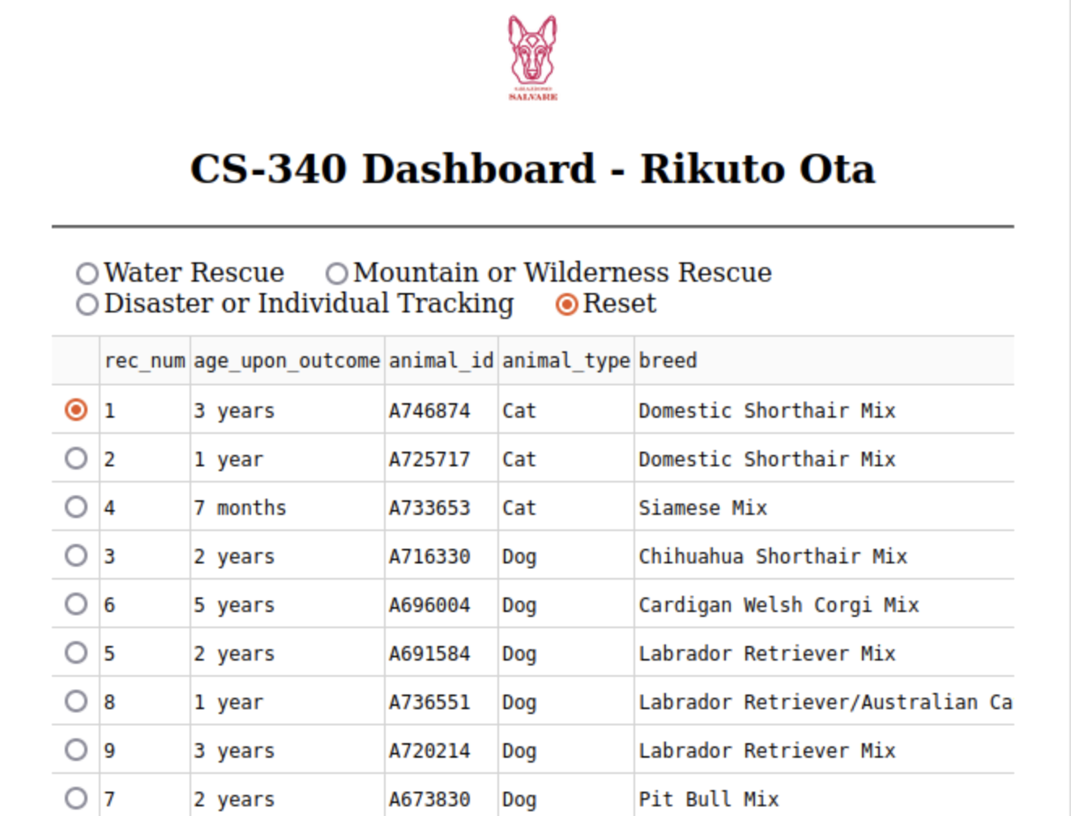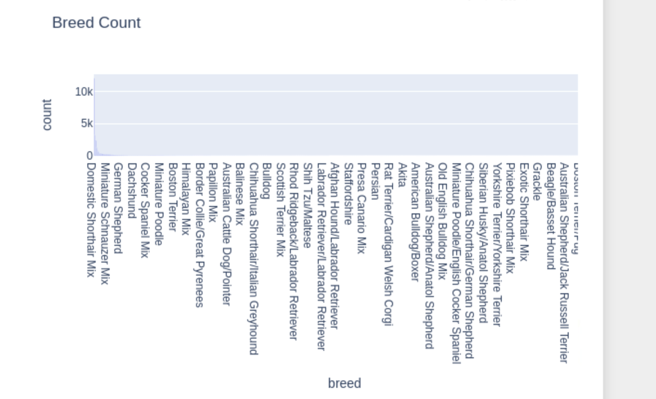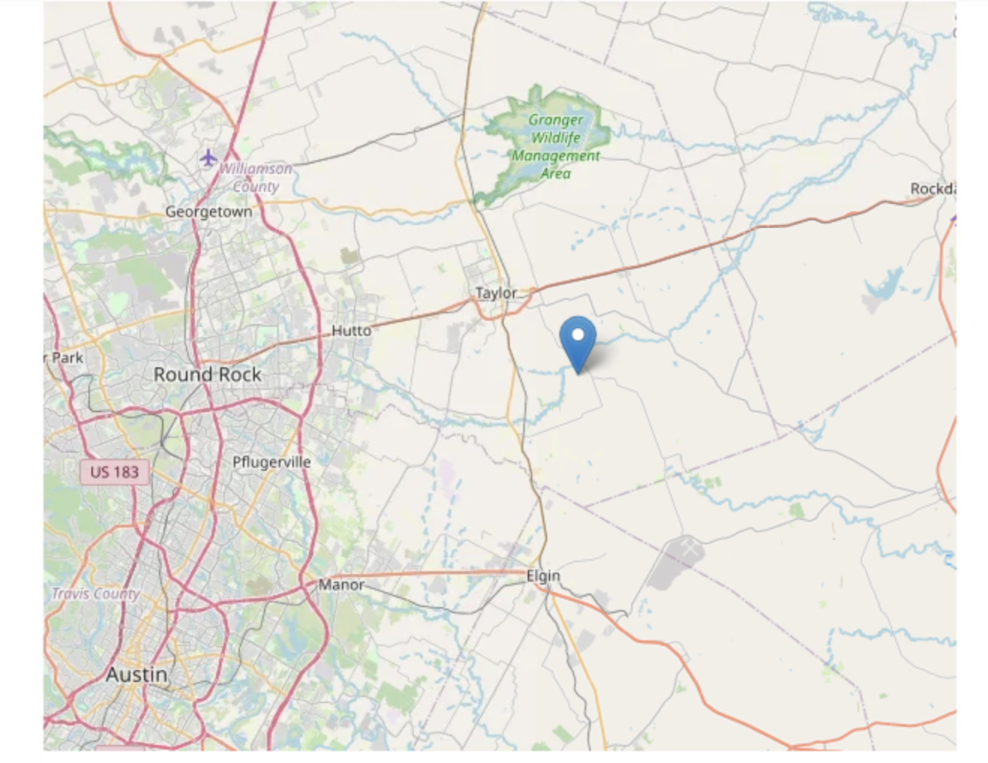Tools Used and Why

- MongoDB: We used this because it works well with flexible data (like different dog info), and it connects easily with Python.  
- Dash: This was used to build the dashboard interface. It lets us make interactive buttons and charts with Python.  
- dash_leaflet: This helped us show dog locations on a map.  
- pandas: This helped us clean and prepare the data to show in the dashboard table.

# Steps Taken to Build the Project

1. I built a Python module (animal_shelter.py) that lets me connect to MongoDB and run CRUD operations.  
2. Then I made the dashboard with Dash inside a Jupyter notebook.  
3. I added dropdowns and filters to choose rescue types.  
4. I made a data table, map, and bar chart that all change based on the filters.  
5. I tested everything and took screenshots.

# Challenges I Faced

- I got a KeyError from the _id field in MongoDB. To fix this, I added a check to remove the _id column only if it exists.  
- I had trouble getting both the chart and map to update when filters changed. I fixed this by carefully using Dash callback functions.

# How to Run the Dashboard

1. Import the animal data CSV file into MongoDB.  
2. Create an aacuser account and set the correct password.  
3. Make sure you have these files:  
 - animal_shelter.py (Python module for MongoDB)  
 - ProjectTwoDashboard.ipynb (Jupyter notebook)  
 - Grazioso Salvare logo image (PNG)  
4. Open the notebook and run it in JupyterDash.  
5. Visit the local URL (like http://localhost:8052) to use the dashboard.

# Resources I Used

- Dash Docs: https://dash.plotly.com  
- MongoDB Docs: https://www.mongodb.com/docs  
- Pandas Docs: https://pandas.pydata.org  
- Animal Data Source: Austin Animal Center Dataset (https://doi.org/10.26000/025.000001)